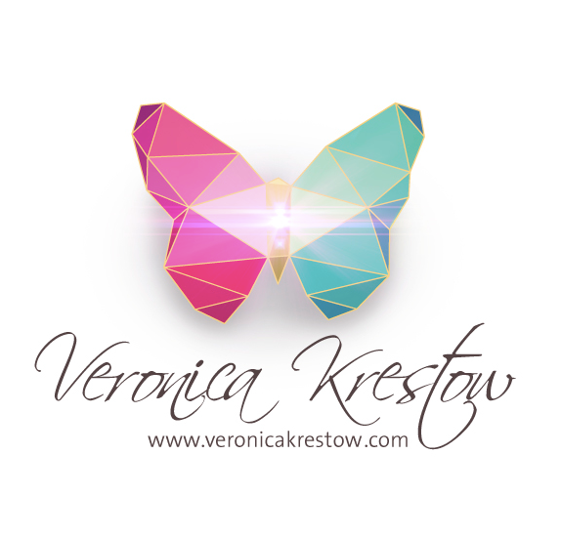

The Diamond Process™ Virtual Coach Training Program Schedule

~2017~

6 Month ~ Diamond Process Program (Level 1)

~February~

2/4: Diamond Process Live Group Session from 10am - 1pm PST

2/6: Diamond Process Video Module 1

2/13: Diamond Process Video Module 2

2/18: Diamond Process Live Group Session from 10am - 1pm PST

2/20: Implementation/Integration week

2/27: Diamond Process Video Module 3

~March~

3/4: Diamond Process Live Group Session from 10am - 1pm PST

3/6: Diamond Process Video Module 4

3/13: Implementation/Integration week

3/18 & 19: Diamond Process Live Group Session (2nd day for DP Coach Program) from 10am - 1pm PST

3/20: Diamond Process Video Module 5

*** The Diamond Process™ Self-Coaching Program Completes here

*** Diamond Process™ Life-Coaching Program Continues

3/27: Diamond Process Video Module 6

~April~

4/1: Diamond Process Live Group Session from 10am - 1pm PST

4/3: Implementation/Integration week

4/10 Diamond Process Video Module 7

4/15: Diamond Process Final Live Group Session from 10am - 1pm PST

4/17: Diamond Process Video Module 8

4/24: Implementation/Integration week

4/29: Diamond Process Live Group Session from 10am - 1pm PST

~May~

5/3 - 5/7: In-person and Virtual Diamond Process Coaching Retreat (additional cost TBD)

Mindful Youtube University™ (Part of Coaching Program)

~May~

5/22, 23, 24 & 25: MYU - Module 1 (1 Video session per day)

5/29: Implementation/Integration week

~June~

6/3: MYU Live Group Session from 11am - 12pm PST

6/5, 6, 7 & 8: MYU Video Module 2 (1 Video session per day)

6/12: Implementation/Integration week

6/17: MYU Live Group Session from 11am - 12pm PST

6/19, 20, 21 & 22: MYU Video Module 3 (1 Video session per day)

6/26: Implementation/Integration week

~July~

7/1: MYU Live Group Session from 11am - 12pm PST

7/3: In-the-field Coach Training begins

7/8: Live Coach Guidance Q&A and training 11AM - 12:15pm PST

7/15 Live Coach Guidance Q&A and training 11AM - 12:15pm PST

7/22 Live Coach Guidance Q&A and training 11AM - 12:15pm PST

7/29 Live Coach Guidance Q&A and training 11AM - 12:15pm PST

The layout of the Diamond Process™ Coach Program…

** 8 Live Teaching Sessions & Peer Practice Mini-Sessions
** 4 Live Q&A Trainings while in-the-field
** 4 Live Q & A’s for MYU
** 12 In-depth Video Module Sessions for MYU
** 8 Modules/25 Video Lessons for Coach Training
** 2 Private Mastery Coaching Sessions for first 5 sign-ups
** 1 Live or Virtual Retreat (additional cost)

Some of what you will be receiving during the program…

1. Short, Digestible Video Trainings
2. Peer Practice Mini-Sessions
3. Group Coaching Calls + Personal Mentoring
4. Exclusive certification in the 7-Step Diamond Process™ system
5. Done-for-you coaching sequences + skill sheets to use with your clients
6. Diamond Process™ Coaching Manual
7. Accountability + Step-by-Step Guidance
8. DP Coaching Community (soul-family + support at its best!)
9. Specific support on “how to build your coaching business”
10. Youtube + Magnetic Video Marketing training
11. Lifetime access to future updates of all course materials
12. Opportunity to be a Diamond Process Coach Assistant in Future Trainings

For more info on the Diamond Process™ Coach Training: http://www.veronicakrestow.com/diamond-process-coach-training-program/

For more info on MYU: http://www.veronicakrestow.com/mindful-youtube-university/

